Proposal for the 65C64

I’ve imagined - like most everyone else on this forum - what a successor to the W65C816 would look like.

I was going to post this in the 65864 thread but felt it would be a bit long and really deserving of it’s own thread. I also remember there is a super thread of all the various architectures members have put together but, unfortunately, as I write this the forum is down so I’m unable to find it.

I’m not putting forward a particularly serious proposal; just a thought experiment to see if I could design up an architecture that felt like it was part of the 65 lineage. To that end I’ve aimed for something that is minimalist and fun to use.

Let’s jump into it.

First off it’s a 64bit architecture – the title should have given that away. Specifically it has a 64 bit ALU and (mostly) 64 bit registers. The databus is 16 bits with 32 bits of addressable memory.

Unlike the ‘816’s 7 registers the 65C64 has 8 (including the program counter).

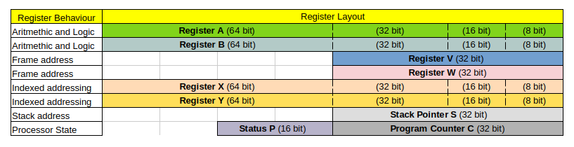
If you’ve used an ‘816 you should be pretty comfortable with registers you see above. An A and B accumulator. Instead of the direct page (DP) there are the two full width offset registers V and W. The stack pointer (S) and the X and Y index registers are exactly as expected.

Except everything I’ve just written is a lie. If you want to use X as an accumulator and do arithmetic on it. Sure, go for it. How about using A, B, X, Y or even S as an offset register? You can do that too.

With a few restrictions any register (including the stack pointer) can be used as an accumulator, offset register, index register or even a stack pointer.

I find that often the quickest way to understand a new architecture is to look at some example code:

Setup:
State Clear X, Y, B
State Set X:4, Y:4, B:8
Pull S: W, X, Y
Sub X, ~8
Sub Y, ~8
Add W, ~8
Loop:
Copy B, X+W
Copy Y+W, B
Sub W, ~8
Branch !Z ~-8 ;Loop

The above copies multiples of 8 bytes from X the source address to Y the destination using W as the number of bytes.
Breaking each line down:

State Clear X, Y, B
State Set X:4, Y:4, B:8

Firstly clear the register width bits for X, Y and B in the Processor Status (P) register. Then set the width of the X register to be 32 bits (4 bytes); the Y register to 32 bits and the B register to 64 bits (8 bytes).

This is the equivalent of a REP followed by a SEP in ‘816 land. Processor state management is the part of the architecture I’m least happy with (and – of course – the first code in the example). Practically this code could be macro’ed out and made to look pretty; and both instructions take up only 4 bytes of memory.

Pull S: W, X, Y

Pull from the stack (S) the registers in order Y, X and W. The similar Push instruction could push any or all of the registers in order: A, B, S, V, W, X, Y using only 2 bytes (just the opcode). Pull works in reverse order.

If the registers are to be pulled in a non-standard order then multiple pull instructions are needed.

Sub X, ~8
Sub Y, ~8
Add W, ~8

Like the instruction INC A encodes A = A + 1 without needing an immediate #1 following the opcode so Add W, ~8 encodes W = W + 8 without an immediate #8. The ~ represents a constant value embedded in the opcode itself. i.e. each of the above commands is 2 bytes.

The allowed embedded constants are 0 through 15 with negative values implied by the ‘Sub’ instruction.

Copy B, X+W

Load the value in address X + W into register B. Using ‘816 registers we would write the the instruction as Copy A, DP+X or more recognisably LDA $00, X.

Copy Y+W, B

Store the value in register B into memory address Y + W. Using ‘816 registers DP and X instead of W and Y then above instruction would be written as STA $00, X.

Sub W, ~8

As before this decrements the W register by 8 but – as in all 65x processors – it also sets the processor status flags carry (C), zero (Z), negative (N) and overflow (V).

Branch !Z ~-8

Branch (jump) the program counter back to Loop if the zero flag is not set. Branches are always relative (to the address of the next opcode following the branch instruction). The branch opcode can either be followed by an immediate signed operand or the opcode itself can encode an small embedded signed value. The latter style is used to branch back to the Loop label as its address is 8 bytes back up from the end of the branch instruction. This branch instruction is encoded in 2 bytes.

I’ve used the copy code above as an example because I was unable to fit the MVN, MVP (and TRB) instructions into the 16 bit opcode encoding. I think that it is alright that they're omitted as the above copies 8 bytes in 10 cycles (best case) and 16 cycles (worst case) which works out to be 1.25 cycles per byte or 2.00 cycles per byte. It could be improved with a dedicated instruction but it is already far faster than the ‘816’s block move instructions.

Next up we’re going to take a look at the high-level block diagram of the 65C64.

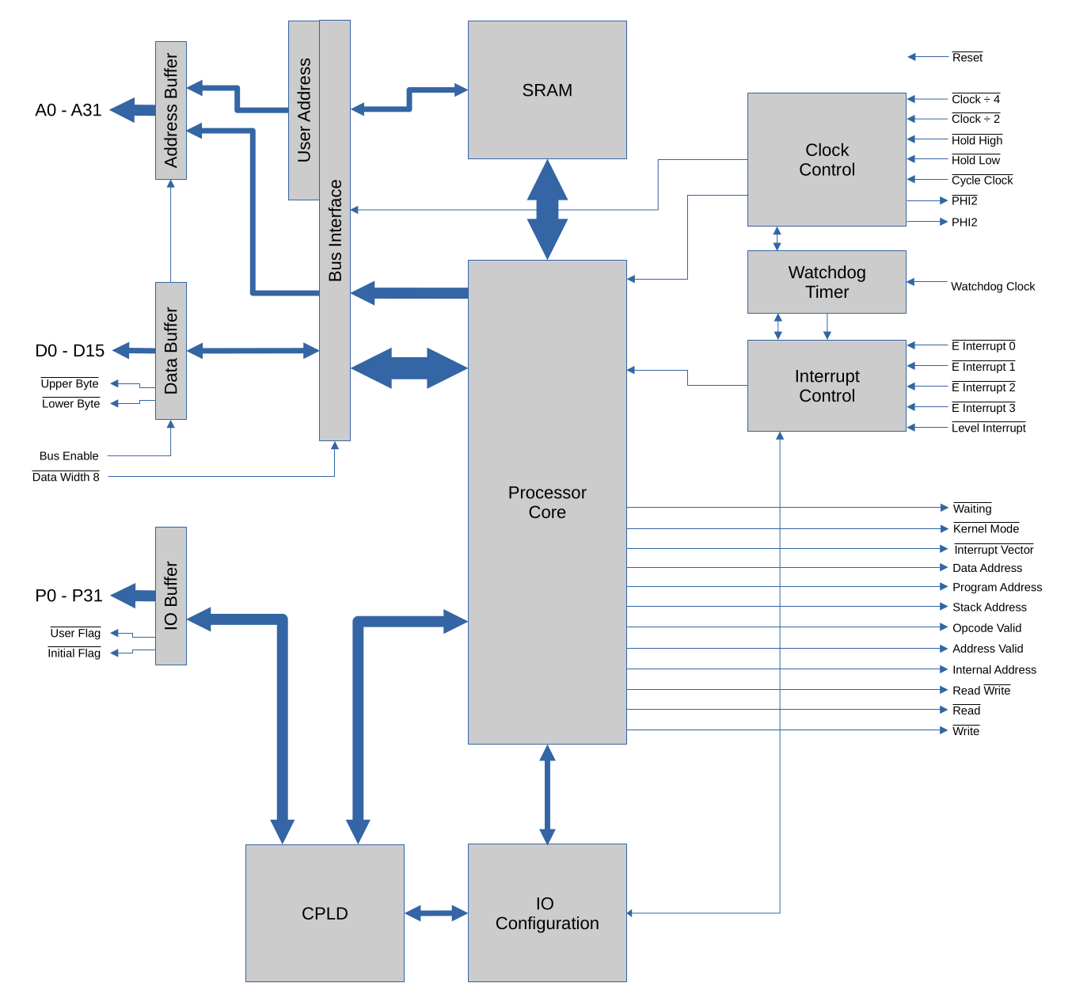

The Processor Core does exactly what you’d expect. It’s largely just a W65C816 with an internal 64 bit data bus and ALU.

I’m going to focus on the surrounding support systems first as they give the 65C64 it’s personality.

A 64 bit processor with a 16 bit databus is a hamstrung processor. The on-chip SRAM can serve as either cache memory or the entire systems memory. Internally it is accessed via a 64 bit databus which allows reads and writes of up to 8 bytes in a single cycle. Though that assumes the data is aligned within a 64 bit boundary – if not then two cycles.

And here is where reality must diverge.

In the perfect world ASICs are easy to manufacture, die size poses no constraints and everything is free. In this perfect world adding 16MB of on-chip SRAM is a no-brainer.

In the real world in which I could conceivably fabricate the 65C64: the on-chip SRAM is really two 32 bit SRAMs strapped together next to a Lattice FPGA on a multi-layer PCB in a PGA package. To keep prices remotely sane I would have to reduce the total on-chip memory to 2MB.

Going forward every statement I make is going to assume the perfect world in which everything is fabricated into a single silicon die, including the 16MB of internal SRAM. Honestly, I’m not going to build this so it will remain a fantasy thought experiment.

Looking at the block diagram again the next interesting feature is the programmable IO pins.

After reset the 32 programmable pins (P0 to P31) are configured as read-only inputs. However the on-chip CPLD can be software programmed into – well – anything a CPLD can do.

I would use it firstly for address decoding. All of the address bus and system control lines are fed into the CPLD which makes it trivial to do device address decoding. Secondly I have some pretty intense clock stretching circuitry that the CPLD could also handle. Thirdly interrupts can be combined and queried.

The CPLD could be programmed as a UART or even a digital audio device. Unfortunately it can’t be used as a video frame buffer as it does not have access to the internal SRAM.

Again here is where reality diverges.

In the perfect world the CPLD is on the die and all it’s fuses are transient (i.e. cleared on reset) and software addressable (I’ll cover the hardware programming instructions in a later post).

In the real world the CPLD is an Altera MAX V 5M160Z (because it’s the physically smallest and cheapest CPLD I can find). A part of the Lattice FPGA will need to be dedicated to programming the CPLD. This is the biggest divergence between the perfect proposal and the real world one.

Two signals (in addition to the 32 programmable pins) also form part of the IO buffer. The Initial Flag is an output that is set low on reset (provided there is a valid external address). The intent being that a ROM is selected on start up; then copied into internal RAM before that ROM is disabled. The Initial Flag is also hardware programmable to output either a low or a high signal.

The User Flag is set high on reset and is programmable to output either a low or a high signal.

Stepping away from the programmable pins there’s really not much else to say.

The address bus is 32 bits and includes a very basic memory management unit that I’ll describe in another post when I discuss Kernel Mode.

The databus is 16 (or 8) bits; the Processor Core can be stunned by the bus interface whilst data wider than 16 bits is fetched (or if the data is not aligned to a 16 bit boundary).

The clock control, watchdog timer and interrupt control probably do exactly what is expected but I’ll cover those in separate post later too.

Just a quick post to look at the pin functions and package. We’re still living in the perfect world in which I can fabricate the 65C64 at a chip foundry (that’s despite me having no experience at all with silicon).

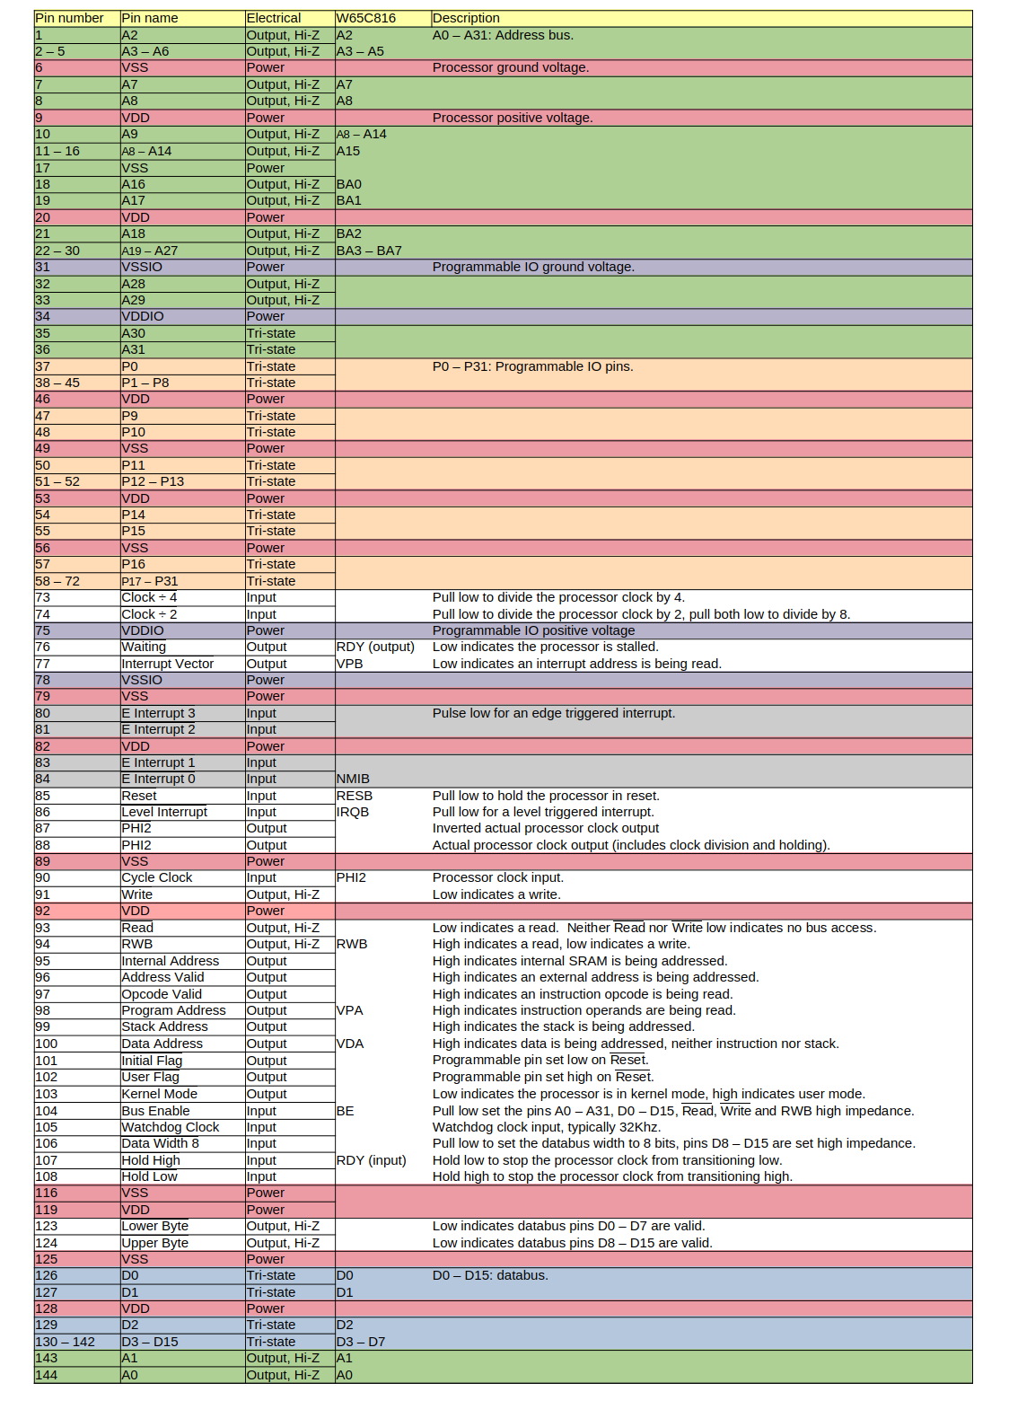
I’m aiming for a full 144 pin QFP package; if you squint it’s still hobbyist possible. And a pin reduced 64 pin QFP package which is basically an ‘816 with an internal 64 bit databus.
The W65C816 column shows the equivalent pin on the ‘816.

The notable features stemming from the pin descriptions are:
- 32 bit address bus (I’ve back and forth’ed on including an DRAM controller but no).
- 16 bit databus.
- 32 programmable IO pins (see my previous post for details)
- 4 edge triggered interrupts (one used by the watchdog timer).
- Clock division by 2, 4 and 8 for the initial ROM load or other slow devices.
- Clock multiplication by 2, 3, 4, 5, 6 and 8 when running internally.
- Kernel / user modes with basic memory management.
- Extended address decoding

That’s about as exciting as it gets.

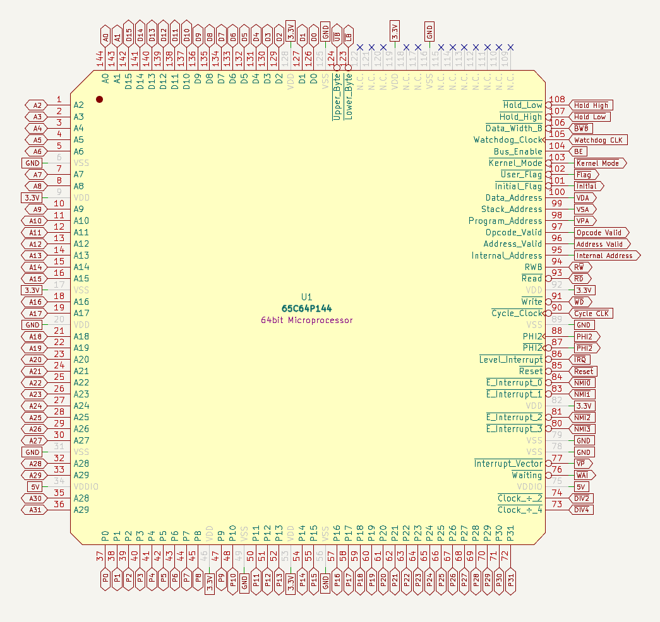

The full QFP 144 pin layout only.

132 pins are used because back in the real world if I were to try and build this it would have to be a (very) overhung pin-grid-array; a PGA132.

Getting to a couple of the arithemtic and logic instructions

